**Operations on EC2 instances**

* Possible list of operations on EC2 instances
  + OS updates
  + Login into EC2 and fix/trouble shoot
  + Starting/Stopping ec2 instances on Some Schedule
* Lab Setup:
  + Let me create two ec2 instances
  + While creating ec2 instances i will add the tag Environment = Dev, Project = QTLearning  
    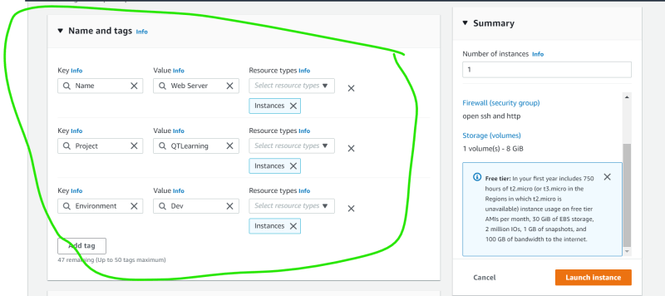
* Now performing common administrative tasks on multiple machines belonging to different project teams is a challenge.
* AWS has EC2 Systems Manager  
  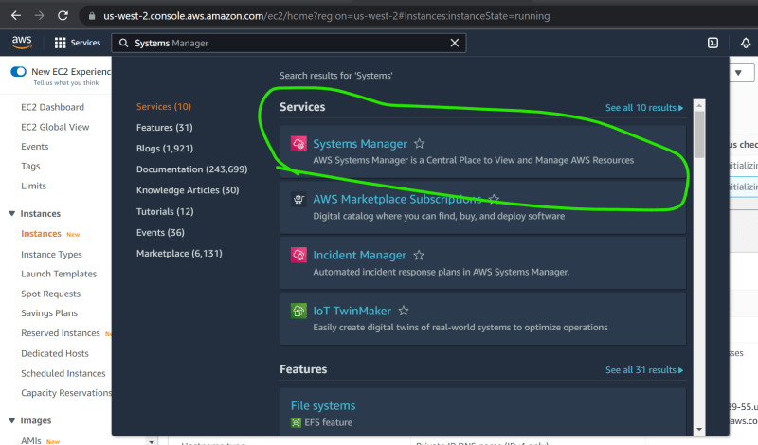

**Systems Manager**

* Systems manager gives central access for operational activities  
  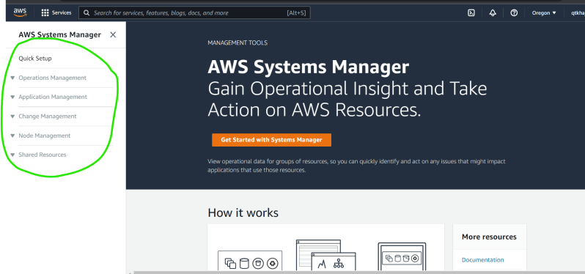
* Now Let’s perform quick setup  
  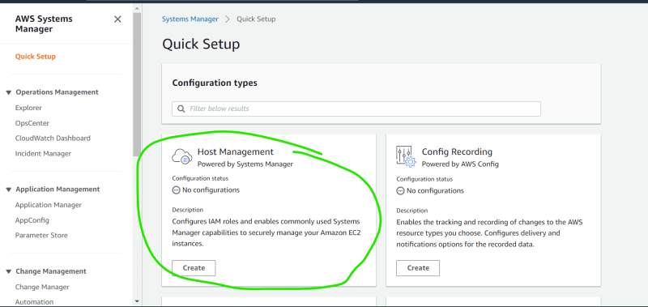
* The Systems Manager interacts with SSM agents on the Ec2 instances, On-prem servers etc to perform operational activities  
  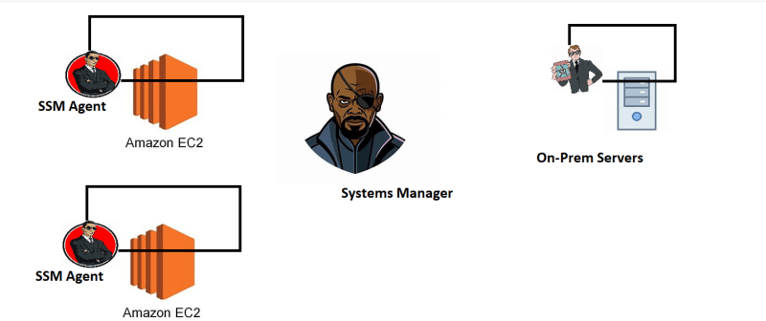  
  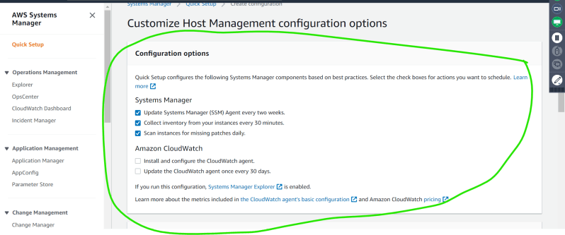  
  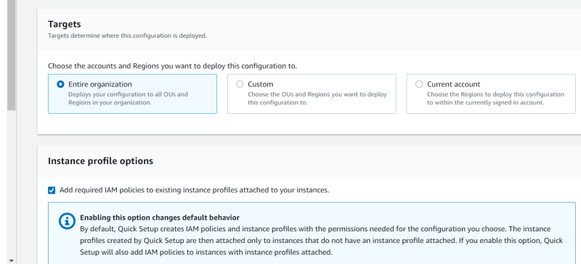  
  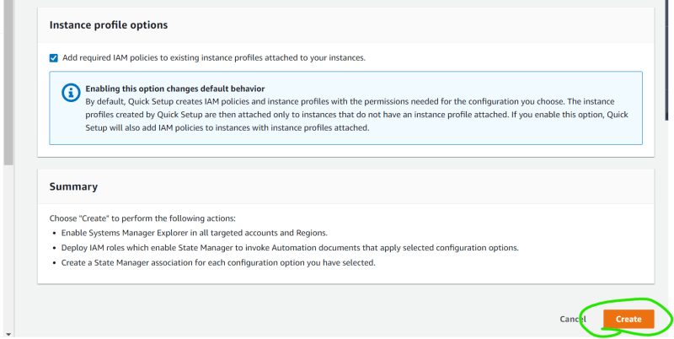  
  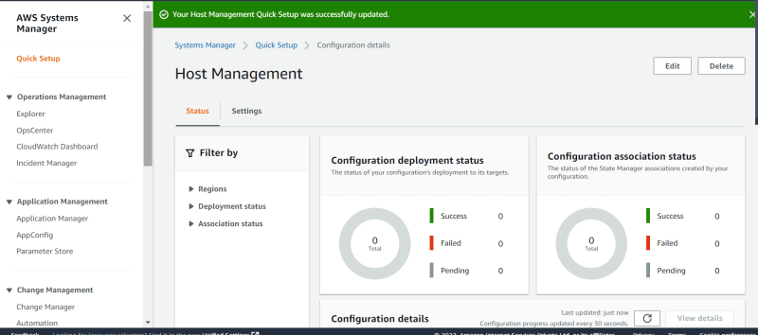
* Now Let’s Navigate to Node Management => Session Manager  
  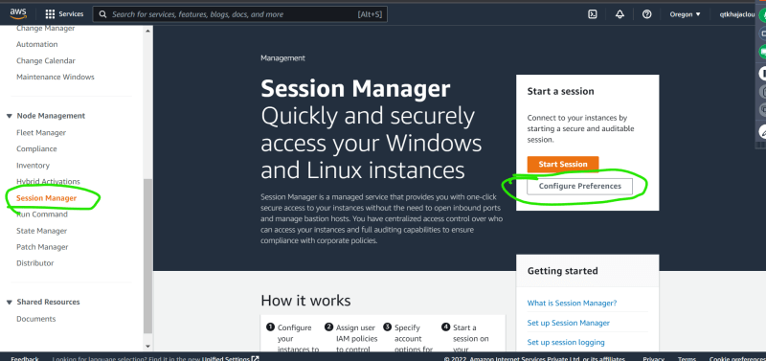
* To view your instances, we need to create IAM Role.
* Run Command => This helps in running a low level linux/windows command on group of ec2 instances.
* For us to make this stuff work, we need to configure ec2 instances with necessary permissions.